**My Food Blog- Kitchen Tales By Madhuri**

1. Home(index.html)- Here I have used the same background for all the pages and in the navigation bar I have 5 links to different pages. I have also set the same footer for all the pages. And for the navigation bar I have used transform:rotate to give a slight different look and background color also changes when we hover over it. And for the footer, I have used social media icons, when you click on it it will be directed to the respective pages.

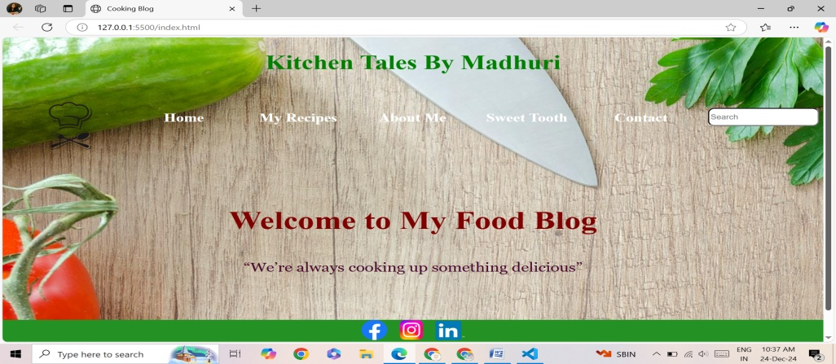

1. My Recipes-When we hover over My Recipe, it has 4 different kind of cuisines. When we click on the respective cuisine, we will be directed to the different page.

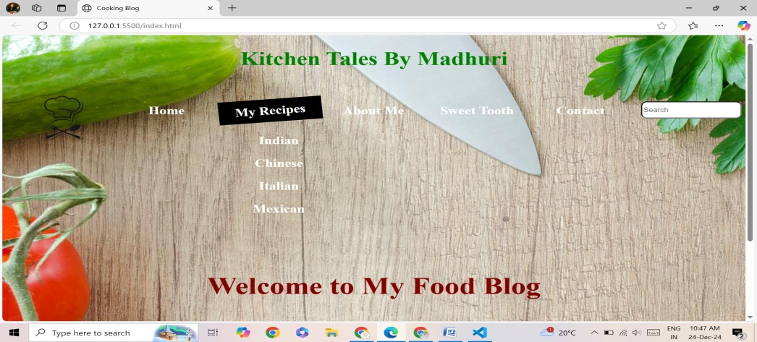

3.About Me-(about.html)-On this page, I have put a video which is auto playing and written a little about me. Navigation bar and footer remains the same. `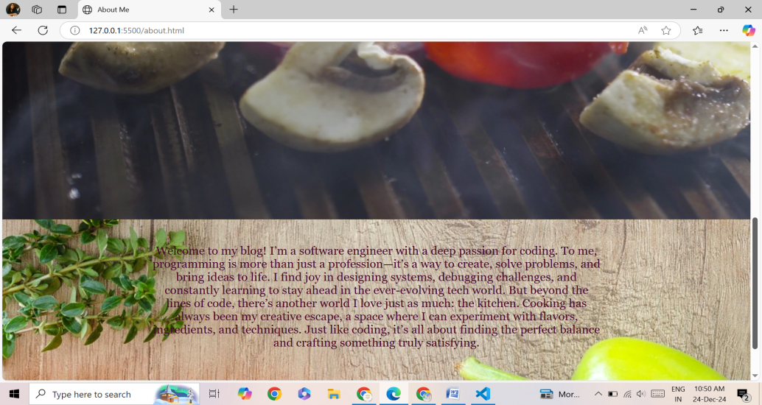

4.Sweet Tooth(myblog.html)- On this page I have used div class= “contatiner” within which I have made the sections for sweets and div classes for different items. Here I have used display grid for the grid items.

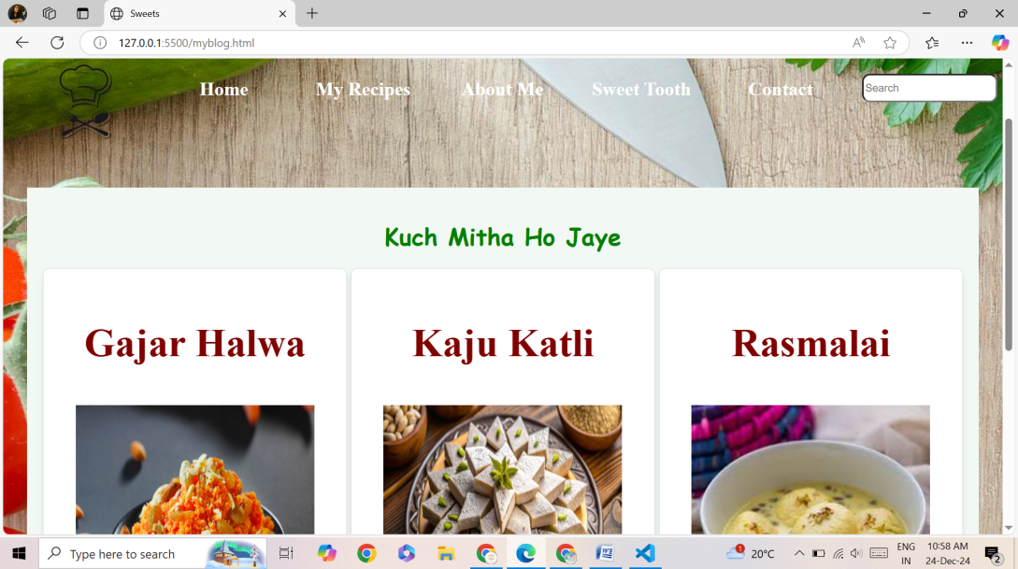

5. Contact(contact.html)- Here I have used form where name, email address and message can be filled with a submit button.

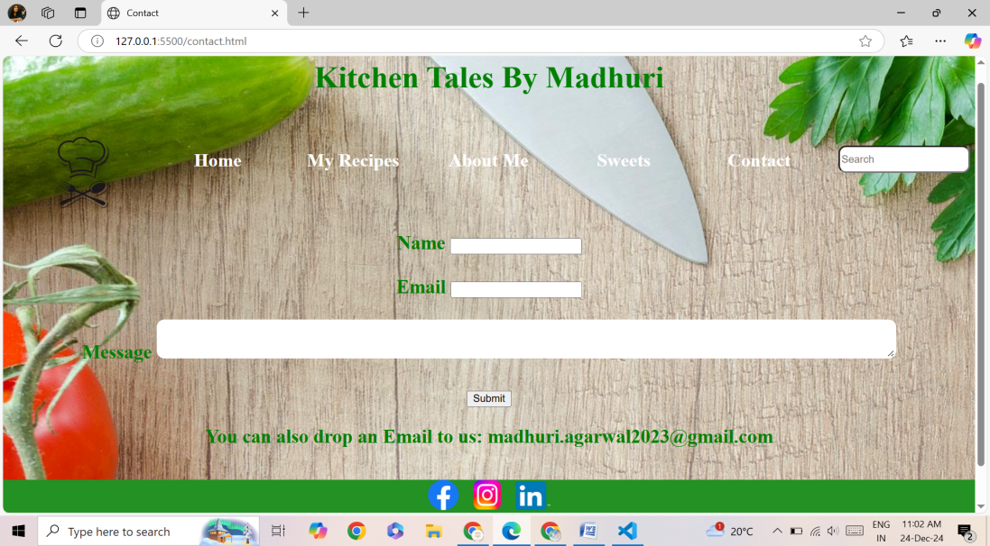

**Thank you..!!**